The New Color Edit in AnzioWin version 12.6

What’s New in Version 12.6

We have added functionality and made configuration easier in this area. First, there is a new "Edit Colors" dialog, under View:Colors. (Note that if Anzio is emulating SCOANSI or certain other terminals, color management is usually done from the host, so settings you might make in Anzio could easily be overridden.) In Edit Colors, you can configure the colors of the text and background that Anzio will use when it is told by the host to display in "blink reverse", for instance.

In the top right of this dialog is "Attribute type". In older versions of Anzio, we used only 8-bit attributes. This meant, for instance, that you could have blinking available, or have underlining available, but not both at once. That is all still possible, if you select "8-bit attributes"; you can choose your "palette" using "Blink / Underline" and "Bright backgrounds". However, if you choose "Full attributes", you have available blink, underline, 16 foreground, and 16 background colors. That is what we recommend. (Certain terminals inherently use 8-bit attributes.)

As mentioned, you have 16 colors to work with. Now, however, we let you fine-tune those 16 colors. Click on the "Change color map" button. The "Color Map" dialog will show you the 16 named colors, and their current settings. If you click any button, you can adjust the color, using a Windows standard color picker. So you could make "green" a little lighter, for instance. You could even make "green" show as purple, although that would be confusing.

All these settings should save into your settings file, and be used on the next startup. In fact, if you run a multi-session environment, such as mscreen or Verssys, you can have separate color settings for each session.

In terminal types VTxxx and ANZIO, you can now make use of the full range of attributes & colors, by sending the appropriate escape sequences from the host. That is, Anzio will respond to escape sequences to set blink, underline, reverse, etc., and also 16 foreground and 15 background colors (for compatibility). When using Pine on Unix/Linux for instance, with Anzio, you can tell Pine to "force-ansi-16color". See README.TXT for more information.

Introduction To AnzioWin Colors
AnzioWin colors are a) associated with particular text attributes that may be sent by the host, b) determined by the terminal type or c) specified by the host. Older versions of AnzioWin worked on an 8-bit attribute color for color handling, while the new versions work on a 16-bit color table approach, making it much more flexible. This new version introduces 16 different text attribute combinations and 16 different color combinations, matching the majority of terminals on the market.

In a non-color terminal, there are 16 possible text attribute combinations. Each has associated with a foreground and a background color. You can select both foreground and background colors from among 16 standard color names and each color name can then be mapped to a specific color available for Windows.

In color terminals, such as ANSI, SCOANSI, at386 and Anzio, 16 different color codes may be sent from the host. These are mapped to a color available for Windows.

Confused yet? Well to summarize the new approach, think of 16 text attributes, each with foreground and background, each mappable to 16 different colors, of which each is mapped to any color available to Windows.

The New Interface
In the past, colors appeared on the main AnzioWin window when you did a Colors Custom… setup. Now they are edited through a Windows dialog reflecting the actual change that takes place. To see this dialog, go to the View menu and select Colors…. The first dialog that comes up varies depending on your terminal type, whether you are working in a terminal type that supports colors or not.

If your terminal type does not support colors, such as the vt100, vt220, etc., colors are related to the text attribute that the host is trying to display. An example would be the mapping of underline text to black text with an underline on a white background as shown below.

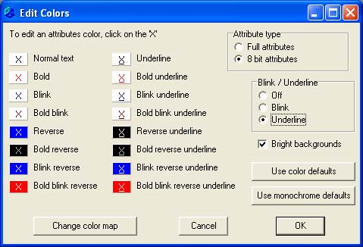

For those terminal types supporting color, you will see the color map dialog which reflects a translation from the host requested color to the actual color Windows will display.

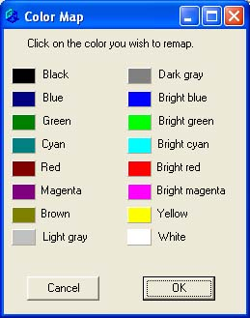

Editing Colors For Attributes (Non-Color Terminals)
If your terminal type does not support colors, such as the vt100, vt220, etc., when you select the Edit : Colors menu item, the following dialog will be displayed. In a non-color environment, AnzioWin colors are related to the text attribute that the host sends with the text. Underline, bold, blink, reverse and normal text are all supported and can be mapped to specific palettes and colors by the user.

Edit an attribute’s color
This area shows the possible attribute the host can send and the color it is mapped to. By clicking on one of the selected text attributes, you can change the color association. This calls up the following Color dialog and allows you to select the color you wish to represent that attribute when the host displays it.

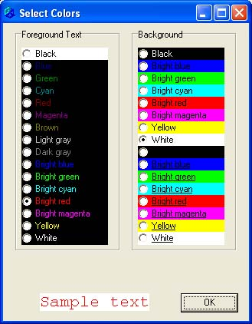

These are the standard 16 colors available under your current color settings (you can change the actual color associated with a name by clicking on the “Change color map” in the prior dialog).

Attribute type
You can set your attribute type to match the old attributes or the new. New attributes use a full 16-color table approach, while old use an 8-bit approach (which precludes having blink and bright and underline all at the same time).

Blink/Underline
This is for 8-bit attributes, to match older AnzioWin colors. You can set the Blink or the Underline bit on, or turn both off, allowing half-intensity colors.

Bright backgrounds
In 8-bit mode, you can also specify whether you want bright backgrounds or not. This dims the palette color for the background which sometimes helps.

Use color defaults / Use monochrome defaults
When you select either of these buttons, a standard mapping of color or monochrome will be loaded.

Change color map
When you select this button, the color map dialog will be displayed. Colors here are associated by name to a specific color available to Windows.

For each black, you can choose a black, for each blue a blue, etc. If you find the yellow too hard on your eyes, you can go here and change the way it is mapped to a Windows color.

By clicking on one of the color panels, such as the yellow square in from of the word Yellow, you can remap what color is yellow. This will bring up the standard Windows color dialog.

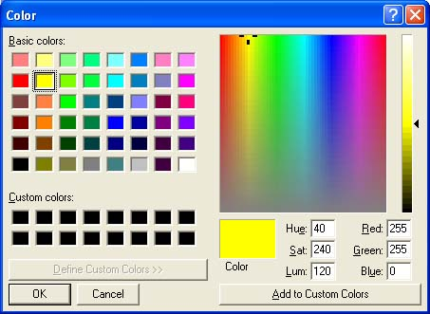

From this dialog, you can then select which color to use to represent yellow.

Editing Color Maps (Color Terminals)
For those terminal types supporting color, you will see the color map dialog when you go to the View : Colors dialog. This reflects a translation from the host requested color to the actual color name AnzioWin will display. Likewise, you can map each of these named colors to an actual Windows color.

For each black, you can choose a black, for each blue, a blue, etc. If you find the red too hard on your eyes, you can go here and change the way it is mapped to a Windows color.

By clicking on one of the color panels, such as the red square in from of the word Red, you can remap what color is red. This will bring up the standard Windows color dialog.

From this dialog, you can then select which color to use to represent red.

Colors From The Host
Your host system can send the color you wish to display. AnzioWin will now respond correctly to the following color codes, regardless of whether the original terminal supported colors or not.

Mode settings are done with
ESC [ <x> m
or
ESC [ <x1> ; <x2> ; <x3> m
(etc.), where each <x> is a number. Values of <x>:

0 Normal (reverts to the "normal" combination configured in color settings)
1 Bold (brightens foreground color)
21 Bold off
4 Underline
24 Underline off
5 Blink
25 Blink off
7 Reverse
8 Invisible
30 Black text
31 Red text
32 Green text
33 Yellow (brown) text
34 Blue text
35 Magenta text
36 Cyan text
37 Gray text
90 Dark gray text
91 Bright red text
92 Bright green text
93 Bright yellow text
94 Bright blue text
95 Bright magenta text
96 Bright cyan text
97 White text
40 Black background
41 Red background
42 Green background
43 Yellow (brown) background
44 Blue background
45 Magenta background
46 Cyan background
47 Gray background
100 Black background (same as 40)
101 Bright red background
102 Bright green background
103 Bright yellow background
104 Bright blue background
105 Bright magenta background
106 Bright cyan background
107 Bright white background

Other notes:
- Screen clears are done in the background color of "normal" text, as configured, not in the current working color.
- Mode 0 (normal) resets to a monochrome mode. Modes 4, 5, and 7 continue in monochrome mode. Any mode 30 to 107 switches to explicit color mode.

